Frequency modulation

EE421 – Experiment 8 Lab Report

by

Aman Khatri, kaman

Experiment performed on 6th April 2011

Report submitted on 10th April 2011

EE 421 - Communications

Department of Electrical and Computer Engineering

The University of Alabama at Birmingham

Lab Team:
Aman Khatri

Douglas Franks

Abstract
In communications, a message is transmitted through open space by electromagnetic waves. These electromagnetic waves, also known as modulating signal, generally contain important messages. Since, these waves travel great deal of distances they need a carrier electromagnetic waves on which they can be modulated. There are several ways of modulating messages on the carrier wave and this lab explores one such type of modulation called, Frequency Modulation which is a sub part of Angle Modulation. In Angle Modulation, the phase of the carrier wave is varied in accordance with the instantaneous value of the message signal while keeping the amplitude of the carrier wave constant. To be specific, in Frequency response this is done by changing the frequency in accordance with message signal. This Lab explores Frequency Modulation.
Table of Contents

Abstract i
Introduction 1
Theory 1
MethodS 1
Experimental Procedure 1
Equipment List 1
Results 3
Conclusions 3
References 6

Introduction

The purpose of this laboratory exercise modulation of a message signal m(t), using frequency modulation and the associated demodulation.

Theory

Let us assume that the carrier wave c(t) is represented by
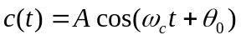 1
Where A is the Amplitude of the carrier wave, ω_{c} is the carrier frequency and θ₀ is some phase angle. If ϕ = 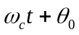 is substituted in the Eq. 1 we get,
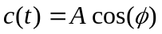 2
Which is the real part of the rotating phasor Ae ^{jϕ} . The equation 2 then becomes,
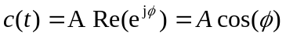 3
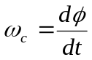This phasor rotates at a constant angular velocity ω_{c} . If ϕ = is differentiated with respect to time t, we get
4

At this point the derivative 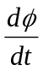 is constant w.r.t time since the carrier wave is unmodulated. However, this derivative may not be constant after certain time. Therefor the angular velocity phasor or the rotating phasor would also vary with the time. Hence, this time-dependent angular velocity or angular frequency is known as instantaneous angular velocity which is denoted by ω_{i} and equation 4 changes to
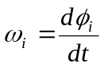
5

In Frequency modulation the instantaneous value of the angular frequency ω_{i} is varied linearly with a message x(t) about an unmodulated carrier frequency ω_{c}. That is the instantaneous value of the angular frequency ω_{i} is equal to the carrier frequency ω_{c} plus a time varying component proportional to the baseband signal x(t). The mathematical model of such wave can be represented as
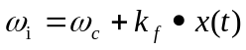 6
Where k_{f} is the proportionality constant and is known as frequency sensitivity of the modulator. This is expressed in Hz/volts. Also, as we can notice from equation 6 that addition of the term k_{f} x(t) leads to variation of frequency. The amount of frequency change from the carrier center frequency is called the frequency deviation. In frequency modulation, the deviation is proportion to the amplitude of the modulating signal. Now to derive an expression for frequency modulated wave we use equation 3 and we get, the expression for frequency modulated wave
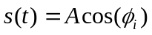 7
where ϕ_{i} is the instantaneous phase angle and base on Eq. 4 and Eq.5 we get
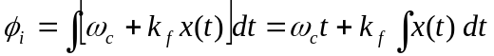 8
And substituting the value of ϕ_{i} in Eq.7 yields the final resultant expression for FM wave over certain amount of time t.
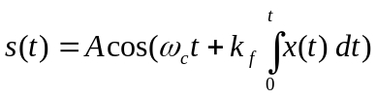 9
For FM, the modulation index (m_{f}) is defined as the ratio of frequency deviation to the modulating frequency. Mathematically,
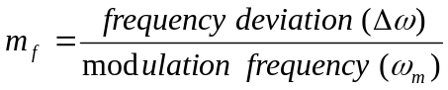 10
Let us assume that x(t) = V_{m} cos (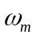t), then equation 9 changes to
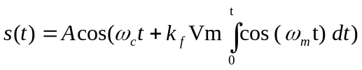 11
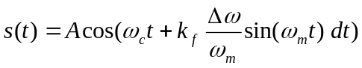 12
We know that
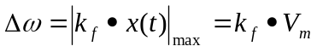 13
And after combining equation 12 and equation 13 we get
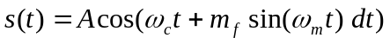 14
Hence, we can conclude that the bandwidth of an FM signal depends upon the frequency deviation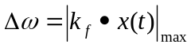. If frequency deviation is high, the bandwidth will be large and vice versa. Therefore, for the bandwidth of a signal depends on frequency sensitivity k_{f}. hence if k_{f} is small the bandwidth is small and the FM is called Narrow Band FM and if k_{f} is large, the bandwidth is wide and the FM is called Wide Band FM.
As we know that only real part of signal exists we can represent the expression 11 can be represented in phasor form as
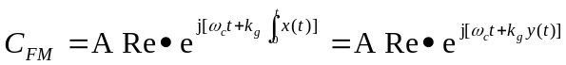 15
Where 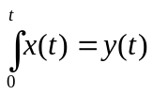. For narrow band FM we have 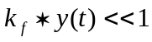for all values of t. thus we can conclude 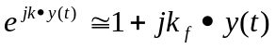and
16
Also, since the FM signal is the real part of its phasor representation, therefore,
17
18
We know that now if we take Fourier transform of this equation then we would have 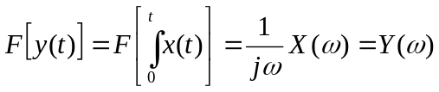. Hence if 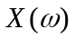 is band-limited to ω_{m}, then 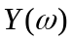is also band-limited to ω_{m}. If x(t) = V_{m} cos (t) then the signal s(t) is given by
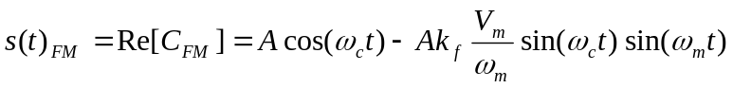 19
Where, 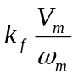 can be replaced by modulation index m_{f}, sometimes referred as β (beta) in the prescribed textbook. In narrow band FM, the value of beta is less than 0.2. For this lab, value of beta is taken to be 0.1.
When the value of modulation index is large in FM, then a large number of sidebands are produced which makes the bandwidth of FM large. This type of FM system is known as wideband FM. If FM signal is represented by equation 14, then the exponential phasor for the signal is represented by
20
As depicted by equation 19, the second exponential is a periodic function of period 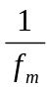and can be expanded in the form of a complex Fourier series:
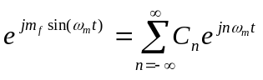for 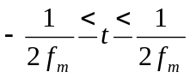, and C_{n} is the coefficient given by 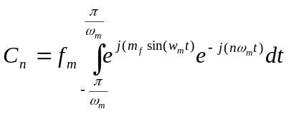, which implies , that 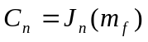that is the n^{th} order Bessel function of the first kind and argument m_{f}. Using this property, we can conclude that the modulated signal s(t) can be represented by
21
The bandwidth of the angle-modulated signal depends on β and frequency of modulating signal (fm). In fact 98% of the total power is contained in the bandwidth
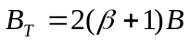 22
Where B is the bandwidth of the modulating signal.

MethodS

Experimental Procedure
The instructions provided by the instructor were followed to complete the laboratory requirements. Please refer to the lab manual on the instructor’s website for details.

Equipment List
FM Demodulator (Part of the sampling test set)
Tektronix FG504 function generator
Hewlett-Packard 3580A Spectrum Analyzer
Hewlett-Packard 54603B Digitizing Oscilloscope

Results

Representations of Waveforms:
- Yellow wave represents modulating signal
- Green wave represents modulated signal
- Blue wave represents recovered signal from the filter.
After making all the connections, the frequency deviation was set to 10KHz. The calculated value of beta was found to be 10. The images obtained shows modulated and modulated signal (Fig.1) and Frequency domain representation of Modulated Signal (Fig.2). The center for the frequency domain was set to 15KHz (which is frequency of carrier wave) and a span of 50KHz do display all the components as clearly as possible. The measured value of beta was found to be same as theoretical value which is 10.
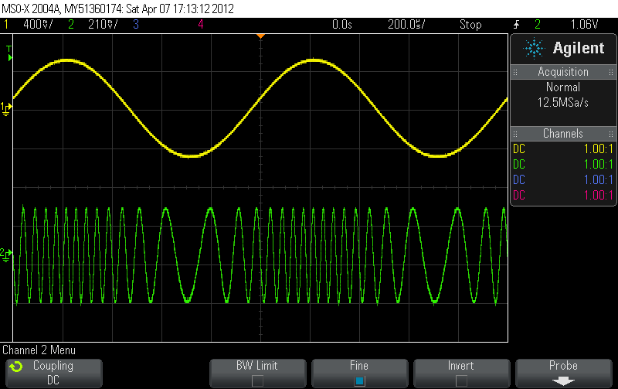
Fig.1 Modulated and Modulated Signals
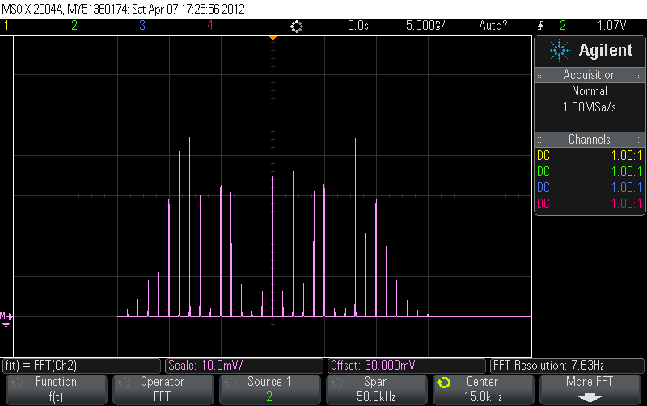
Fig.2 Frequency Domain representation of Modulated Signal
At this point, a value of 0.1 was used for beta. The display of modulated and modulating signal was captured in Fig.3. The frequency display of the modulated signal was captured in Fig.4. The time domain representation of the signal obtained from the variable filter is shown in Fig.5 and Fig.6 shows the frequency domain representation of the recovered signal. The bandwidth of the signal was 100Hz. The center for the frequency domain was set to 15KHz (which is frequency of carrier wave) and a span of 10KHz do display all the components as clearly as possible.

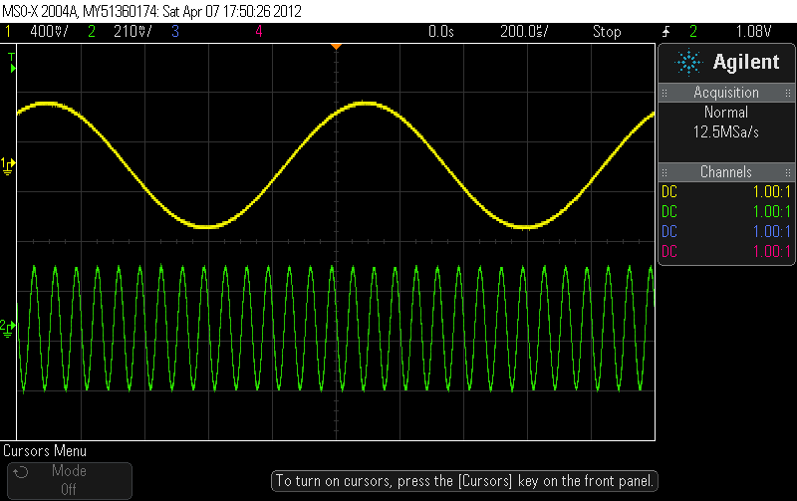
Fig. 3 Modulated and Modulating Signals
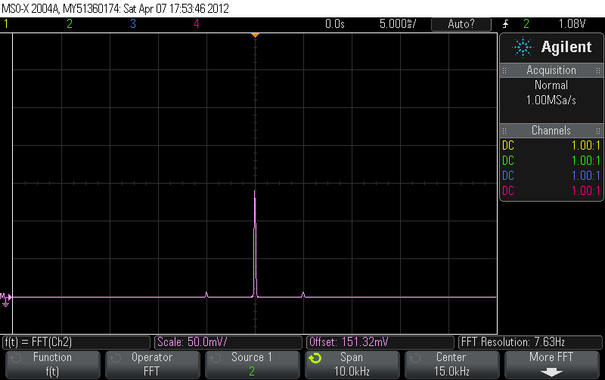
Fig. 4 Frequency Domain representation of Modulated Signal.
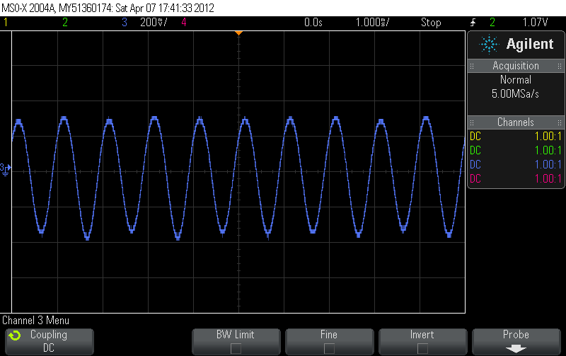
Fig. 5 Recovered Signal from Filter.
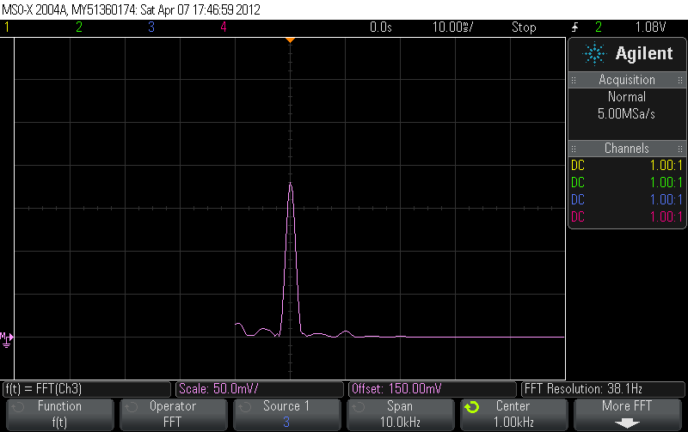
Fig. 6 Recovered Signals in Frequency Domain
The frequency deviation was then changed until the carrier component went to zero. The frequency deviation at this point was 2.4KHz, and the bandwidth of the signal was 1KHz. The time domain representation and Frequency domain representation of the modulated and modulated signal is shown Fig.7 and Fig.8. The center for the frequency domain was set to 15KHz (which is frequency of carrier wave) and a span of 50KHz do display all the components as clearly as possible. At this point it can be visualized that the center which is 15KHz has a zero component.
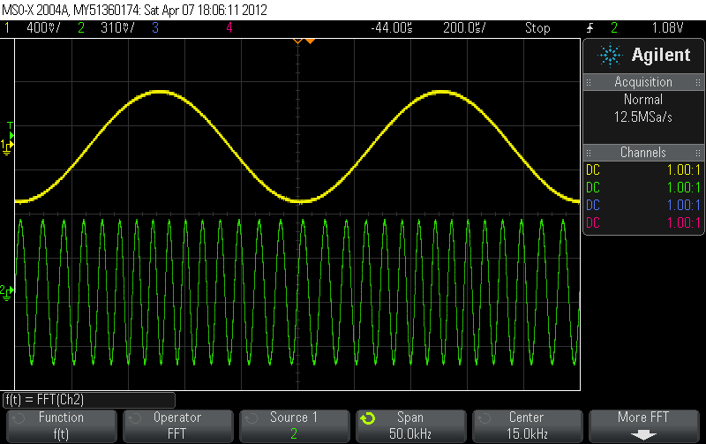
Fig. 7 Modulated and Modulating Signal
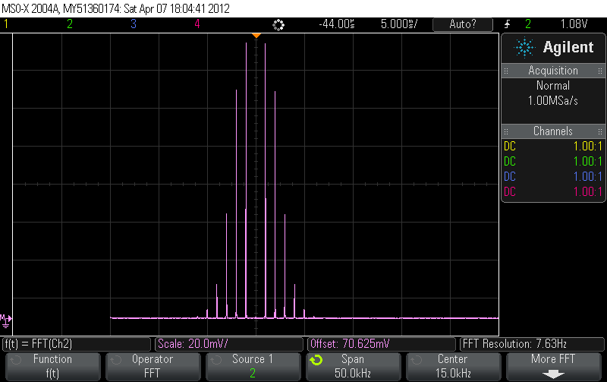
Fig. 7 Frequency domain representation of Modulated Signal
The frequency deviation was then doubled. The frequency at this point was 4.8 KHz, beta of 4.8 and the bandwidth of the signal was 5.8 KHz. The time domain representation and Frequency domain representation of the modulated and modulated signal is shown Fig.9 and Fig.10. The center for the frequency domain was set to 15 KHz (which is frequency of carrier wave) and a span of 20KHz do display all the components as clearly as possible. The observed bandwidth was 14KHz.
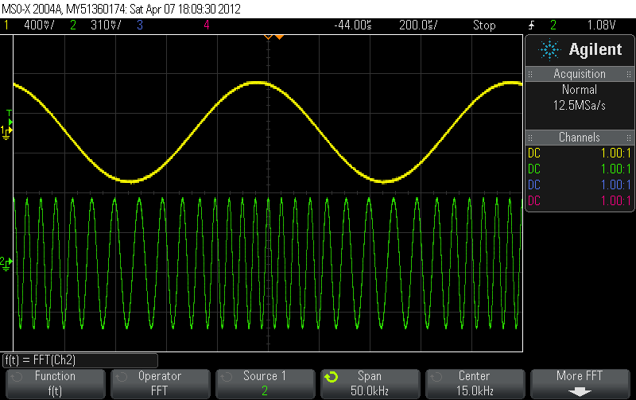
Fig. 8 Modulated and Modulating Signal
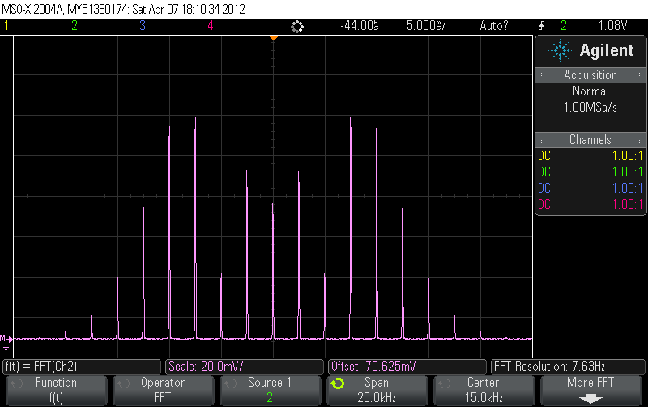
Fig. 9 Frequency domain representation of Modulated Signal
The modulating was then doubled. The modulating frequency at this point was 2 KHz, and the Frequency deviation of the signal was 4.8 KHz. The time domain representation and Frequency domain representation of the modulated and modulated signal is shown Fig.10 and Fig.11. The center for the frequency domain was set to 15 KHz (which is frequency of carrier wave) and a span of 50KHz do display all the components as clearly as possible. The carrier component at this setting was observed to be zero.
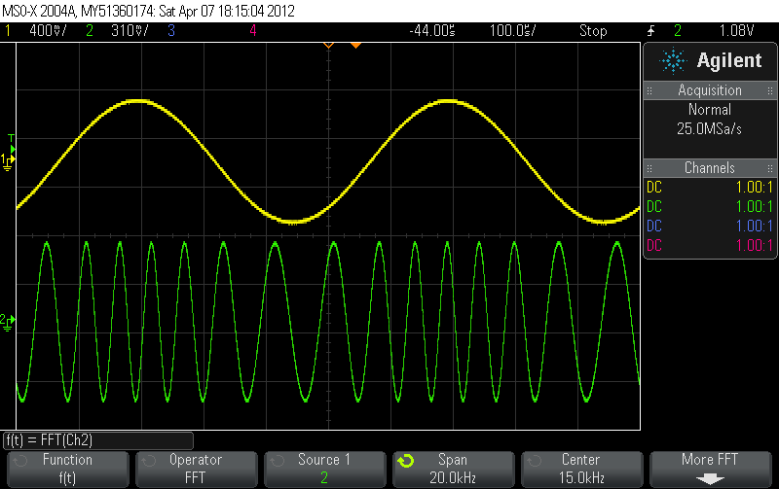
Fig. 10 Modulated and Modulating Signal

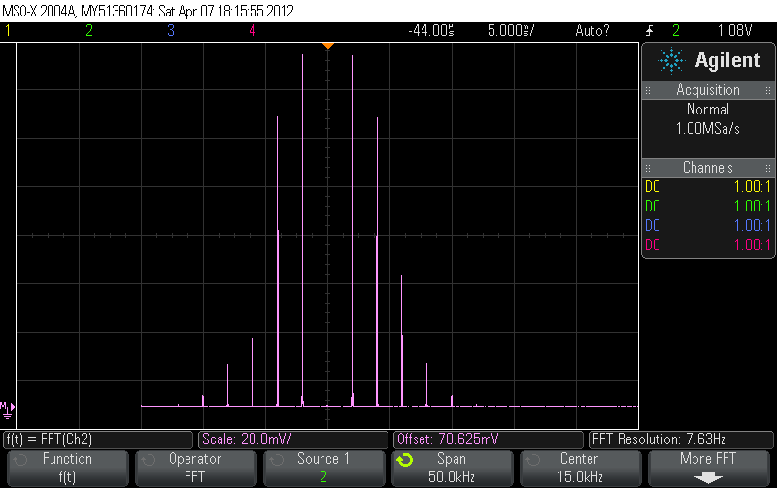
Fig. 11 Frequency domain representation of Modulated Signal
The modulating was then doubled again. The modulating frequency at this point was 4KHz, and the Frequency deviation of the signal was 4.8KHz. The time domain representation and Frequency domain representation of the modulated and modulated signal is shown Fig.12 and Fig.13. The center for the frequency domain was set to 15KHz (which is frequency of carrier wave) and a span of 50KHz do display all the components as clearly as possible.
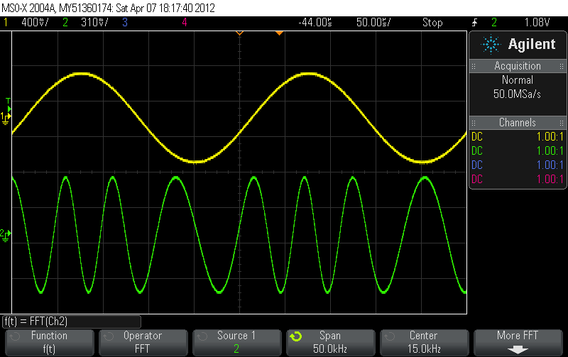
Fig. 12 Modulated and Modulating Signal

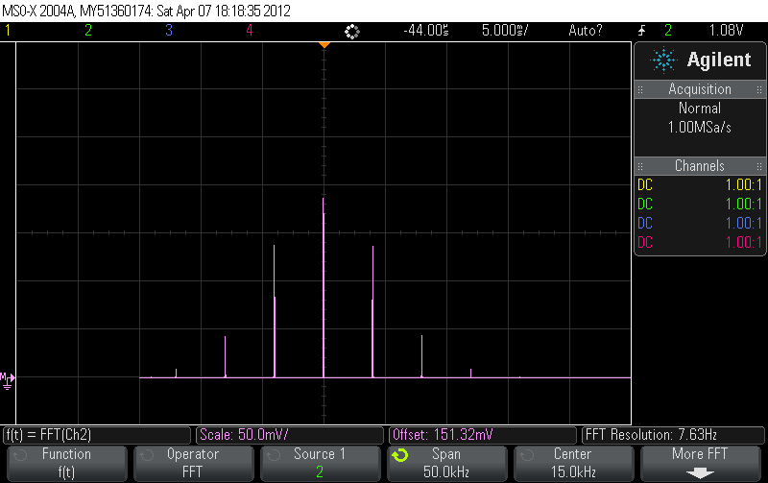
Fig. 13 Frequency domain representation of Modulated Signal

The frequency deviation was then halved. The frequency deviation at this point was 2.4 KHz, beta of 0.6 and the bandwidth of the signal was 7.68 KHz. The time domain representation and Frequency domain representation of the modulated and modulated signal is shown Fig.14 and Fig.15. The center for the frequency domain was set to 15KHz (which is frequency of carrier wave) and a span of 20KHz do display all the components as clearly as possible.
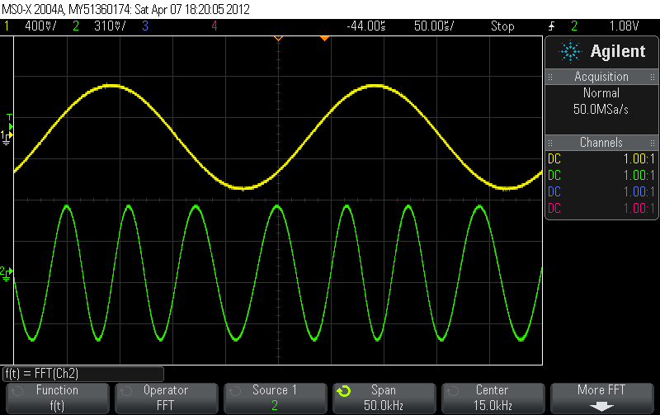
Fig. 14 Modulated and Modulating Signal

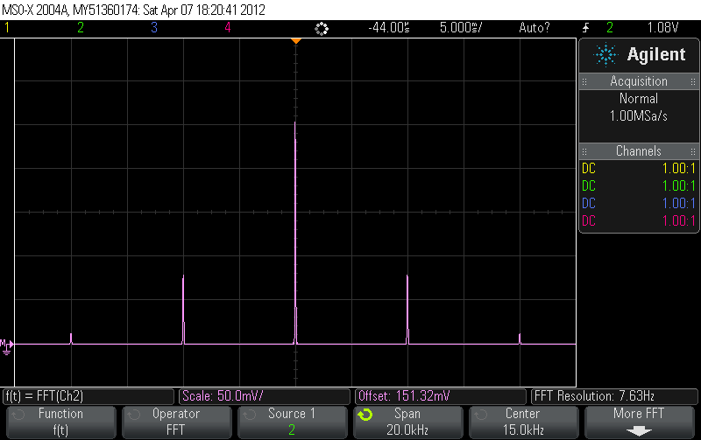
Fig. 15 Frequency domain representation of Modulated Signal

DISCUSSION
The theoretical value beta matched the experimental value of beta. The value of beta changes with the change in frequency deviation and the change in the frequency of modulating signal. The beta is given by the term in Eq.19, which states, that if the frequency of modulating signal is increased the value of beta decreases, and as the value of frequency deviation increases, the value of beta increases. The value of beta changes the number of spikes in frequency domain as, the frequency spectrum of any signal for the wideband is dependent upon the Bessel function. Eq. 20 shows how the number of spectral line changes according to the value of beta, and the weight (Amplitude) of each spectral line.

Conclusions
The experiment was very useful in understanding the concept of frequency modulation. The experiment also helped us understand the method of recovering the digital signal using frequency modulation.

References
- Leon w. Couch, II, “Digital and Analog Communication Systems”, Sampling Theorem, pp. 87-90,2007.
- Sanjay Sharma, Communications System , “Angle Modulation, pp 220-300

